Distributed Systems in a Smart City Traffic Management System
Modern municipal infrastructure increasingly depends on distributed computing to deliver real-time, city-wide services. The smart traffic management system described in this scenario, which links intersection sensors, cameras, public transport GPS feeds, a central data center, and citizen mobile applications, is a clear illustration of a distributed system in practice. Van Steen and Tanenbaum (2016) define a distributed system as a collection of autonomous computing elements that appears to its users as a single coherent system. This essay explains how the traffic system reflects that definition, identifies the communication protocols that connect its components, and evaluates the challenges of remote execution for real-time decision making.
Distributed architecture and the benefit of a distributed approach
The traffic management system is distributed because it consists of many independent nodes, including street sensors, traffic cameras, GPS receivers on public transport, and citizen smartphones, that must work together while appearing to citizens as one unified service. Each node behaves autonomously and reacts to its own inputs, yet collaborates through message passing to achieve the shared goal of monitoring traffic (van Steen & Tanenbaum, 2016). Most raw data travels to a central data center for heavy processing, such as predicting congestion patterns across the entire city, while simple, urgent alerts, for example an accident warning, are generated directly at the sensor. This local processing reflects edge computing, which Arvindpdmn and Pravardhan (2022) describe as moving intelligence closer to the source of data, such as an IoT device or gateway, so that time-critical analysis does not have to wait for a round trip to a distant server.
Figure 1 illustrates this layered architecture. At the edge layer, sensors and cameras perform lightweight, immediate processing and issue local alerts. These devices also forward richer data upward to the central data center, which performs computationally heavy analysis, such as citywide congestion modeling, and pushes results outward to the mobile application layer used by citizens.
Figure 1
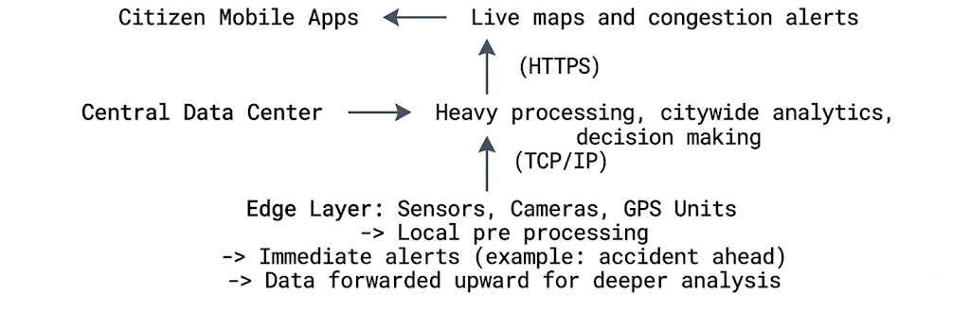
Note. Simplified architecture of the smart traffic management system, showing the edge layer, the central data center, and the citizen-facing application layer.
The primary benefit of this distributed, edge-aware approach over a fully centralized design, in which every sensor sends raw data to one single point with no local processing, is a substantial reduction in latency and network bandwidth. Arvindpdmn and Pravardhan (2022) explain that when devices have enough storage and compute power to analyze data locally, only the important segments need to be transmitted onward, which saves bandwidth and lets the central system support many more devices. For this traffic system, an accident warning can therefore be issued within milliseconds at the intersection itself rather than waiting for raw video to travel to a data center and back, a delay that could be dangerous. A fully centralized design would also create a single point of failure and a severe bottleneck, since Rellermeyer (2023) notes that centralized services quickly become constrained by computational, storage, and network capacity as the number of connected devices grows.
Communication protocols in the traffic system
Several communication protocols work together to move information from street sensors to the central processing unit and finally to citizens. At the foundation, Transmission Control Protocol and Internet Protocol, commonly paired as TCP or IP, provide the backbone of communication. Internet Protocol assigns addresses to every sensor, camera, and server and determines how packets are routed across the city network, while Transmission Control Protocol ensures that data packets, such as sensor readings, arrive completely, in the correct order, and without corruption (van Steen & Tanenbaum, 2016). This reliability is essential when the central data center is reconstructing a continuous stream of traffic data from many sensors at once.
Once data reaches the application layer, Hypertext Transfer Protocol Secure, or HTTPS, is the protocol most likely used to deliver live traffic maps and congestion warnings to citizens through their mobile apps. ByteByteGo (2024) explains that HTTPS builds on the standard HTTP request and response model while adding an encrypted layer, so a citizen requesting a live traffic map receives an authentic response that cannot easily be intercepted. Domain Name System, or DNS, also plays a supporting role by translating the human-readable address of the traffic data service into the numerical Internet Protocol address that mobile devices actually use to connect (Rellermeyer, 2023). Dynamic Host Configuration Protocol, or DHCP, would likely operate within the sensor network itself, automatically assigning addresses to newly installed sensors or cameras so technicians do not need to manually configure every added device. Finally, encryption protocols such as Transport Layer Security work alongside HTTPS to protect sensitive data, including GPS location information from public transport vehicles, as it travels between devices and the central data center. Together, these protocols show that even a seemingly simple citizen facing traffic app depends on a coordinated stack of addressing, routing, reliability, and security protocols operating largely out of sight.
Challenges and trade-offs of remote execution
Relying on remote execution at a central data center for analyzing vast amounts of traffic data introduces meaningful challenges. The first is latency. Van Steen and Tanenbaum (2016) note that a wide-area distributed system cannot hide the physical limits imposed by signal transmission and network congestion, meaning that decisions requiring input from many distant sensors will always take measurably longer than decisions made locally. For a traffic system, this trade-off means the most urgent, safety-related alerts must remain at the edge, while broader optimization tasks, such as adjusting signal timing across an entire district, can tolerate the delay of central processing.
A second challenge concerns scalability and reliability. As the number of sensors, cameras, and connected vehicles grows, the central data center risks becoming a bottleneck, and Rellermeyer (2023) emphasizes that resource management and scheduling in large distributed systems must balance the competing goals of fairness, cost, and responsiveness among many simultaneous data streams. Furthermore, failure transparency becomes difficult to guarantee. Van Steen and Tanenbaum (2016) point out that it is often impossible to distinguish between a sensor that has genuinely failed and one that is simply responding slowly, which complicates the decision of whether to trust or discard incoming data during a possible malfunction.
A third trade-off involves consistency versus availability. If the system tries to keep every citizen app perfectly synchronized with the very latest sensor readings at all times, it risks delays during network disruptions, yet if it favors availability by showing slightly outdated maps, citizens may receive congestion warnings that no longer reflect current conditions. This tension reflects the broader difficulty, described by van Steen and Tanenbaum (2016), of achieving consistency, availability, and tolerance of network partitions simultaneously in a distributed system. Security and privacy add a final layer of complexity, since transmitting continuous location data from public transport and citizen devices requires careful encryption and access control to prevent misuse, all while the system must remain fast enough to support genuinely real time decision making.
Conclusion
The smart traffic management system illustrates how distributed computing, edge processing, and layered communication protocols combine to serve a city in real time. By processing urgent alerts locally while reserving heavy analysis for a central data center, the city gains lower latency and better scalability than a fully centralized alternative could offer. However, this approach still requires careful management of communication protocols and a thoughtful balance between the speed, reliability, and consistency trade-offs inherent to any large-scale distributed system.
References
Arvindpdmn, P. D., & Pravardhan. (2022, February 15). Edge computing. Devopedia. https://devopedia.org/edge-computing
ByteByteGo. (2024). Top 8 most popular network protocols explained [Video]. YouTube.
Rellermeyer, J. (2023, August 29). Modern distributed systems. OpenCourseWare. https://ocw.tudelft.nl/courses/modern-distributed-systems/
van Steen, M., & Tanenbaum, A. S. (2016). A brief introduction to distributed systems. Computing, 98(9), 967–1009. https://doi.org/10.1007/s00607-016-0508-7

